**What the Rise of Off-Road Hybrids Says About Where SUVs Are Headed**

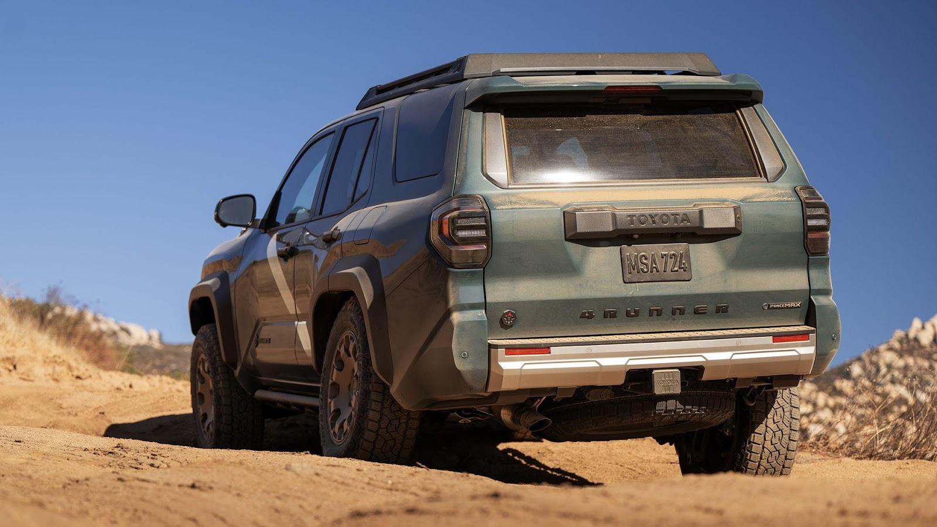

Not long ago, the idea of a “hybrid off-roader” felt like a contradiction. Hybrid technology was mostly about maximizing mileage in urban commutes, not crawling up a ridge or crossing muddy trails. But in 2025, things look very different. From Toyota and Jeep to Land Rover, hybrid technology is no longer just about being eco-friendly.

It’s now being used to boost torque, smooth out trail performance, and deliver more usable power off the pavement. So what does this shift really mean? Are hybrids just a temporary bridge until full EVs take over or are we looking at a new chapter for adventure-capable SUVs, one where electrification enhances the experience rather than compromises it?

**Not Just Fuel Economy: What Hybrids Actually Offer Off-Road**

Say “hybrid,” and most people picture a quiet city commuter, not a lifted SUV clawing up muddy hills. But in today’s off-road scene, hybrid systems are doing more than saving fuel. By combining gas-engine torque with instant electric drive, they bring serious advantages to the trail. Electric motors deliver immediate force from zero RPM, making them perfect for rock crawling and steep climbs where traditional engines need time to catch up.

Electric assist also smooths out throttle input, reducing wheelspin and improving traction in loose or slippery conditions. Many hybrid setups now feature electric all-wheel drive (e-AWD), which distributes traction more precisely than mechanical systems in tight, technical terrain. The result goes beyond efficiency, offering better control and traction right when it matters most. Vehicles like the Jeep Wrangler 4xe are already proving how [capable hybrid off-roaders](https://carbuzz.com/hybrid-off-road-vehicles/) can be. Low-end muscle matters when the terrain gets unpredictable, and hybrids are built to deliver it the moment your tires leave the pavement.

**The Big Three: Toyota, Jeep and Land Rover**

[Three major players are pushing hybrid off-roaders into the mainstream](https://www.cnn.com/2025/03/14/business/hybrids-vs-evs-strategy-auto/index.html) – and doing so with very different strategies.

**1. Toyota: Hybrid as Standard**

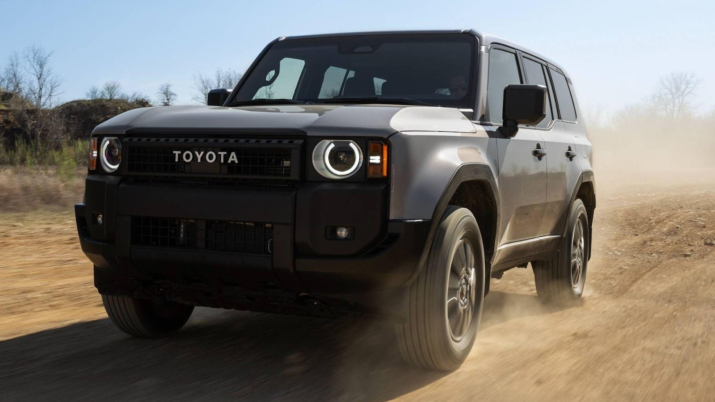

[Toyota has committed to hybridizing nearly its entire SUV lineup](https://www.toyota.com/hybrid/). The new **Land Cruiser**, [**4Runner**](https://pressroom.toyota.com/the-all-new-2025-toyota-4runner-the-icon-that-inspires-exploration/) and **Tacoma** all come standard with hybrid powertrains in the U.S. market. This isn’t a premium upgrade – it’s the baseline. The Land Cruiser, for instance, now features a **2.4-liter turbocharged hybrid system** producing **326 hp** and **465 lb-ft of torque**, paired with full-time four-wheel drive and a locking center differential.

That torque figure? Higher than the outgoing V8. Toyota’s hybrids also integrate seamlessly with existing off-road hardware: crawl control, multi-terrain select and disconnecting sway bars are all still on the menu. In other words, capability hasn’t been sacrificed — it’s been enhanced.

**2. Jeep: Torque-Focused Trail Hybrids**



[Jeep took a different route with its **4xe** program, using **plug-in hybrids**](https://www.jeep.com/ev/technology.html) to blend trail performance with limited electric-only operation. The **Wrangler 4xe** delivers 375 hp and 470 lb-ft of torque — more than the gas V6 and comparable to the outgoing V8 Rubicon 392. It can also drive **up to 21 miles** in electric-only mode, useful for quiet trail rides or urban trips between trails.

More importantly, the electric motor fills torque gaps during throttle transitions, making rock-crawling smoother and hill climbs easier. Jeep even runs **EV-only trail experiences** in Moab to showcase the tech’s quiet strength. The same PHEV setup is now offered in the **Grand Cherokee 4xe**, with similar performance benefits.

**3. Land Rover: Silent Luxury Meets Trail Tech**

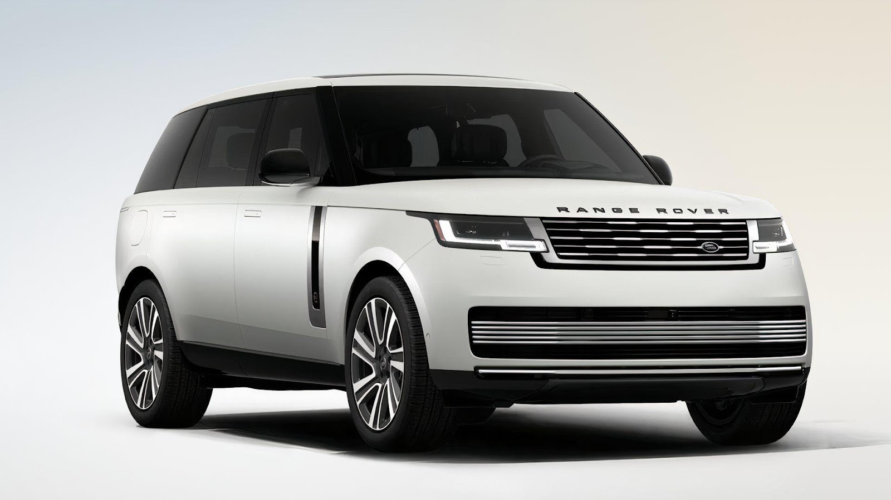

[Land Rover’s move into hybrid off-roading is quieter, but arguably more refined](https://www.rangerover.com/en-us/electric/suv.html). The brand’s **Range Rover Sport PHEV** and **Defender P400e** use plug-in hybrid setups that prioritize torque fill and silent driving at low speeds.

The **Defender P400e**, for example, pairs a turbocharged four-cylinder engine with a 105-kW electric motor, yielding **398 hp** and **472 lb-ft of torque**. It can drive over **30 miles** on electricity alone and retains Land Rover’s legendary off-road software suite. More than just power, the hybrid system adds sophistication to off-road driving. It offers precise crawl control, seamless torque delivery, and the ability to ease over obstacles silently and smoothly.

**Why Hybrids Work Where EVs (Still) Struggle**

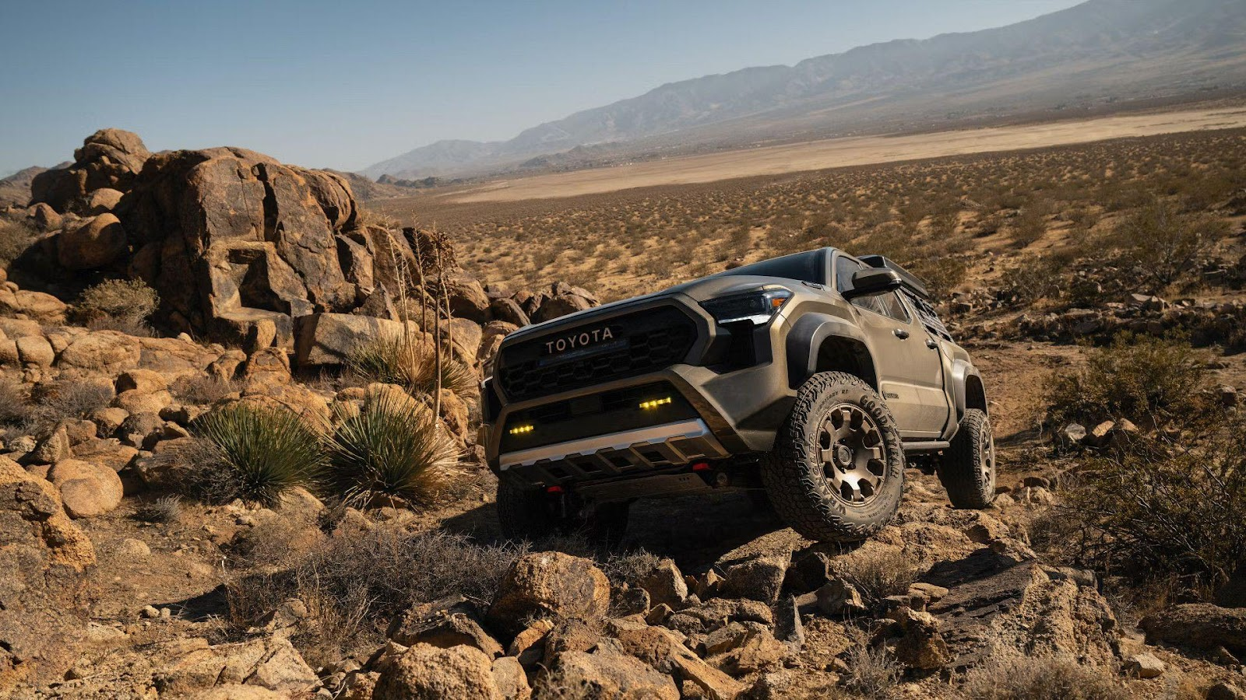

While full EVs offer excellent torque and low-speed control, their **off-road range** is still a real challenge. Between cooling demands, elevation changes and a lack of charging infrastructure, it’s hard to commit to full-day or multi-day trail runs in a pure EV – unless you're very well prepared.

Hybrids avoid this problem. They give drivers:

* **Electric torque for trail work**
* **A gas engine for range extension**
* **No dependency on chargers**

That’s why hybrid systems, especially plug-in variants, feel like a smart middle ground. They bring the benefits of electrification without the limitations of full battery power. And in real-world testing, many hybrid off-roaders **outperform** their gas-only counterparts in hill climbing, torque control and traction modulation.

**Where It’s Headed: Performance, Not Just Efficiency**

The most interesting thing about this trend? It’s not being driven by fuel economy mandates – it’s being driven by **performance advantages**.

We’re entering an era where electrification is being applied to amplify off-road capability, not just to reduce emissions. That’s a critical shift. In the next wave of hybrid off-roaders, expect more rear-motor setups designed to enhance torque vectoring and improve handling on uneven terrain.

Automakers are also developing smarter trail navigation software that can adjust torque delivery based on changing surfaces in real time. At the same time, hybrid battery systems are being reengineered for trail performance. They’re becoming lighter, more compact, and tuned to prioritize low-end torque over long-range electric driving. This could very well become the new norm for adventure SUVs: a hybrid powertrain tuned for torque, not for tax credits.

**Can You Really Tune for Personality?**

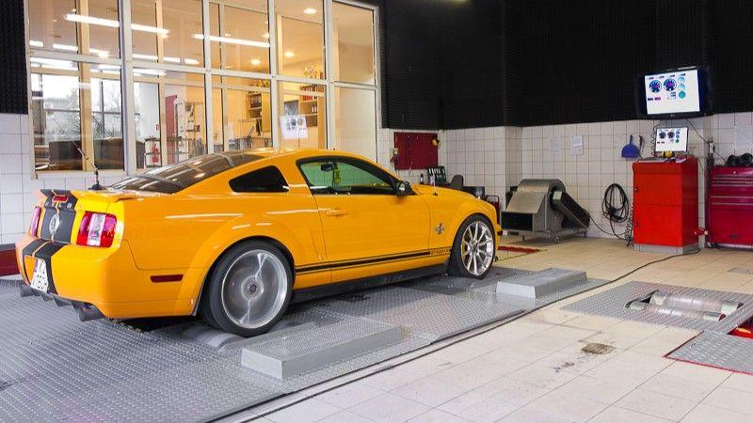

Here’s the harder part. Going fast is easy with electricity. The Tesla Model S Plaid, for example, hits 60 mph in 2 seconds with no tuning at all. But enthusiasts want more than speed. They want feedback. Grit. Something mechanical to connect with. [So, can tuning *give* that to an EV](https://www.sema.org/news-media/enews/2022/23/breakthroughs-ev-tuning-success-performance-modifications)? Some builders think yes. By sharpening steering feel, dialing in more dynamic regen settings and modulating traction control systems to allow a bit more slip or rotation, tuners are injecting engagement into cars that often feel antiseptic.

Others are experimenting with synthesized soundtracks – not just loudspeaker exhaust noise, but real-time performance-linked audio cues that rise and fall with torque demand. It’s not everyone’s cup of tea, but it’s part of the new toolkit for shaping EV character. And then there’s design. Wider fenders, ducktail spoilers, functional diffusers – many EV tuners are borrowing cues from traditional tuner culture to give these silent machines more presence. And unlike ICE platforms, EV bodies often leave room for creative cooling solutions and wild underbody aero.

**A New Type of Customer — and a New Tuner Identity**

It’s not just the cars that are different. It’s the people. While ICE tuning catered heavily to gearheads and longtime enthusiasts, EV performance is attracting a different demographic: younger buyers, early adopters and tech-savvy owners who are more likely to code than wrench. This shift is influencing how shops communicate, brand and even deliver services.

Instead of dyno runs and track days, EV tuners often emphasize software diagnostics, over-the-air updates and app-based customization. It’s a different vibe, but it’s still performance culture — just redefined for a new era.

**Spec Snapshot: What Tuners Are Working With**



**Platform Stock Output Tuned Focus**

Tesla Model 3 Perf 455 hp, AWD Aero, suspension, brakes

Lucid Air GT 819 hp, AWD Thermal, battery maps

[Porsche Taycan](https://carbuzz.com/news/porsche-taycan-with-3835-lb-ft-of-torque-is-the-future-of-ev-tuning/) 750 hp (Turbo S) Chassis, weight, range

Hyundai Ioniq 5 N 641 hp (Boost) Drift mode tuning, visuals

These platforms aren’t just fast – they’re modular. That makes them ripe for experimentation, especially as more independent developers gain access to OEM APIs and diagnostic tools.

**The Legal and Warranty Hurdles**

Of course, not everything is plug-and-play. Unlike with ICE vehicles, [many EVs restrict access to performance settings through locked ECUs or proprietary software](https://carbuzz.com/news/dodge-ceo-goes-on-record-abut-ev-tuning-and-hacking/). Tuning often voids warranties and battery mismanagement can have serious consequences – not just for performance, but for safety.

As a result, many shops walk a fine line: optimizing only what’s accessible or focusing on bolt-on performance. In some cases, builders partner with OEMs or suppliers to develop “approved” upgrades. This is especially common in Europe, where tuning regulations are more strictly enforced. Still, as EV adoption increases, aftermarket solutions will become more standardized – and safer.

**So, Can EVs Have a Tuned Soul?**

Not in the traditional sense. There’s no cam lope, no exhaust note, no manual gearbox to row through. But that doesn’t mean EV tuning is soulless. Instead, it's becoming something else – quieter, smarter and in some ways, more creative. You’re not tuning explosions anymore; you’re shaping code, current and control.

And if the goal of tuning has always been to make a car feel more personal, more responsive and more alive – then yes, tuners *can* give EVs a soul. They just have to redefine what the soul looks (and sounds) like in a world without pistons.